**Assignment**

**Probability & Statistics fall 2022**

**Instructions:**

* Assignment must include the title page that contains your roll number, full name, section, date, and submission date etc.
* Solve each question step by step otherwise marks will be deducted.
* Calculations for questions 13 to 19 can be done on MS-Excel.
* Take snapshots of your hand written assignment and convert it into PDF format.
* Submit assignment in PDF format via Google classroom.
* Deadline of submission will be followed strictly.
* **Copy / Paste / plagiarism not allowed**

**Full Name: Muhammad Hussain Javed**

**Roll No.: 21K-3584**

**Section: BCY-3A**

**Submission date: 2/10/2022**

**Ages of CEOS (CLO-1)**

you are given the ages for the CEOs of the 60 top-ranked small companies in America in 1993.

(Data source: Forbes, “America’s Best Small Companies,” Nov. 8, 1993; also at [http://lib.stat.cmu.edu/DASL/Datafles/ceodat.html](http://lib.stat.cmu.edu/DASL/Datafiles/ceodat.html) )

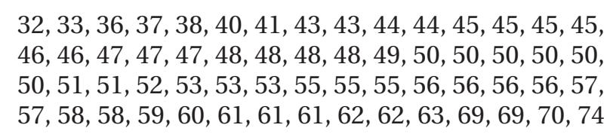

**[10 points]**

1. Create a stem-and-leaf plot for these ages.
2. Create a dotplot for these ages.
3. Describe the shape of this dataset.
4. Are there any outliers in this dataset?
5. In general, would outliers be more likely to occur in the salaries of heads of companies or in the ages of heads of companies? Explain

**Solution:** (paste step by step hand written solution here)

